“Darkness at Noon” By Harold Krents
1. Blind from birth, I have never had the opportunity to see myself and have been completely dependent on the image I create in the eye of the observer. To date it has not been narcissistic.
2. There are those who assume that since I can’t see, I obviously also cannot hear. Very often people will converse with me at the top of their lungs, enunciating each word very carefully. Conversely, people will also often whisper, assuming that since my eyes don’t work, my ears don’t either.
3. For example, when I go to the airport and ask the ticket agent for assistance to the plane, he or she will invariably pick up the phone, call a ground hostess, and whisper: “Hi, Jane, we’ve got a 76 here.” I have concluded that the word blind is not used, for one of two reasons: Either they fear that if the dread word is spoken, the ticket agent’s retina will immediately detach, or they are reluctant to inform me of my condition, of which I may not have been previously aware.
4. On the other hand, others know that of course I can hear, but believe that I can’t talk. Often, therefore, when my wife and I go out to dinner, a waiter or waitress will ask Kit if “he would like a drink” to which I respond that “indeed he would.”
5. This point was graphically driven home to me while we were in England. I had been given a year’s leave of absence from my Washington law firm to study for a diploma in law at Oxford University. During the year I became ill and was hospitalized. Immediately after admission, I was wheeled down to the X-ray room. Just at the door sat an elderly woman—elderly I would judge from the sound of her voice. “What is his name?” the woman asked the orderly who had been wheeling me.
6. “What’s your name?” the orderly repeated to me.
7. “Harold Krents,” I replied.
8. “Harold Krents,” he repeated.
9. “When was he born?”
10. “When were you born?”
11. “November 5, 1944,” I responded.
12. “November 5, 1944,” the orderly intoned.
13. This procedure continued for approximately five minutes, at which point even my saintlike disposition deserted me. “Look,” I finally blurted out, “this is absolutely ridiculous. Okay, granted I can’t see, but it’s got to have become pretty clear to both of you that I don’t need an interpreter.”
14. “He says he doesn’t need an interpreter,” the orderly reported to the woman.
15. The toughest misconception of all is the view that because I can’t see, I can’t work. I was turned down by over forty law firms because of my blindness, even though my qualifications included a cum laude degree from Harvard College and a good ranking in my Harvard Law School class.
16. The attempt to find employment, the continuous frustration of being told that it was impossible for a blind person to practice law, the rejection letters, based not on my lack of ability but rather on my disability, will always remain one of the most disillusioning experiences of my life.
17. Fortunately, this view of limitation and exclusion is beginning to change. On April 16, [1978,] the Department of Labor issued regulations that mandate equal-employment opportunities for the handicapped. By and large, the business community’s response to offering employment to the disabled has been enthusiastic.
18. I therefore look forward to the day, with the expectation that it is certain to come, when employers will view their handicapped workers as a little child did me years ago when my family still lived in Scarsdale.
19. I was playing basketball with my father in our back yard according to procedures we had developed. My father would stand beneath the hoop, shout, and I would shoot over his head at the basket attached to our garage. Our next-door neighbor, aged five, wandered over into our yard with a playmate. “He’s blind,” our neighbor whispered to her friend in a voice that could be heard distinctly by Dad and me. Dad shot and missed; I did the same. Dad hit the rim; I missed entirely; Dad shot and missed the garage entirely. “Which one is blind?” whispered back the little friend.
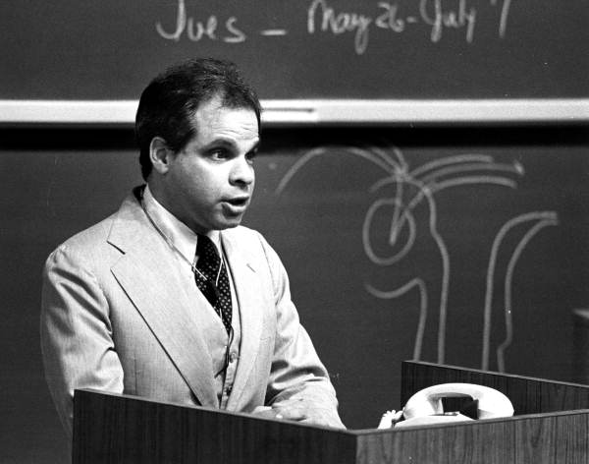
20. I would hope that in the near future, when a plant manager is touring the factory with the foreman and comes upon a handicapped and a non- handicapped person working together, his comment after watching them work will be, “Which one is disabled?”
About the Author: Harold Krents
Harold Eliot Krents, was born in Manhattan, graduated from Scarsdale High School in 1963, from Harvard College, cum laude, in 1967, and from Harvard Law School in 1970. In 1974 he spent a year at Oxford University in England and received a law degree from University College. He passed the New York bar examination and went on to work for the Washington-based law firm of Surrey, Karasik & Morse, now Surrey & Morse, a firm involved in defending the rights of the disabled.
In 1980 he became a White House Fellow, assigned to Patricia Roberts Harris, the Secretary of Health, Education and Welfare. Earlier he had been a member of the President's Committee on Employment of the Handicapped.
Mr. Krents was a supporter of the 1973 Rehabilitation Act passed by Congress, an act intended to protect the legal rights and employment of the handicapped.
In 1975 Mr. Krents founded Mainstream Inc., a nonprofit group that promotes the legal rights of the disabled.
ALL WORK MUST BE DONE IN THE NOTEBOOK TO RECEIVE CREDIT!!!
ARTICLE # 7 Darkness at Noon by Harold Krents
I. Text Preview: Students should preview and annotate the text for main ideas and rhetorical devices the author uses to make his argument. In their previews they should think about what that title could mean and the meaning of narcissistic.
II. Reading and Annotation: Students should independently read and annotate the text for main ideas and rhetorical devices the author uses to make his argument.
III Post-Reading Questions:
1) Describe this essay’s tone. How does Harold Krents build that tone throughout the essay? Why does an author need to think about tone in an argument?
2) What point is Krents making with his use of anecdotes about the airport, the hospital and the basketball game?

3) Circle the conclusion of the essay. How does Krents end his essay? What is the effect of this ending on readers?

4) What is the main idea of Krents’ essay? What is he arguing? Why did he write this essay?

5) Vocabulary problem solving:
Work together to define any words you are still not sure of. Try to figure them out in the context of the article and your knowledge of word parts. Look up any words you cannot figure out but be sure the definition you write down fits the way the word is used in the text read.

IV Whole Class Discussion: Discuss student answers to the questions, especially the questions about tone and Krent’s use of anecdotes. Students should add notes about how authors build tone into their academic journals and any new learning on writing and reading openings and conclusions.

ARTICLE # 8 ‘Handicapped’ Symbol Gets Facelift by Shaun Heasley
I. Text Preview: Students should preview and annotate the text for main ideas and rhetorical devices the author uses to make his argument. They should look at the image and consider it.
II. Reading and Annotation: Students should independently read the short text about a proposed new handicap sign in New York, along with the comments people have added to the on-line text. They should annotate the text, including the comments for the differing perspectives and issues raised.
III. Writing: In an AXES style paragraph, explain: Should California update the handicapped symbol? Why or why not?

‘Handicapped’ Symbol Gets Facelift By Shaun Heasley
May 28, 2013 http://www.disabilityscoop.com/2013/05/28/handicapped-symbol-facelift/18034/
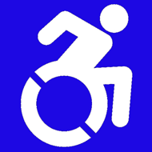
An effort to revamp the icon that’s long symbolized accessibility on everything from parking lot signs to bathrooms is gaining traction with New York City agreeing to adopt a new look.
An updated version of the seemingly ubiquitous blue and white “handicapped” symbol will soon be plastered across New York.
New York City plans to adopt a redesigned Handicapped Sign
Rather than depict a static person in a wheelchair, the new icon displays an active, in-motion version of life with a physical disability.
“It’s such a forward-moving thing,” Victor Calise, commissioner of the New York mayor’s Office for People With Disabilities, told The Chronicle of Higher Education.
Backers of the new icon, which was spearheaded by a philosophy professor at Gordon College in Massachusetts, say they hope that adoption by the nation’s largest city will lead to more widespread acceptance of the design.

Comments (48 Responses)
- Gene says: May 28, 2013 at 3:50 pm That’s a great image and a wonderful idea. Now, how do you overcome the fact that it doesn’t meet the 2010 Standards?
- Patrick Maher says: May 28, 2013 at 4:35 pm Now if we could just get journalists to refer to the symbol as something other than “handicapped” we’d really be making progress. Maybe “accessibility” symbol?
- Leaping Larry says: May 28, 2013 at 4:56 pm As a person that has used a wheelchair for mobility since 1982 that was born with spina bifida.I really like the new sign and hope it is adopted by City, County, State, Nation and Internationally. :)
- Gael McCarthy says: May 28, 2013 at 4:56 pm I’m in an assisted wheelchair due to Polio when I was four. I am not sure that the symbol needs to be changed at all. It has taken years and years to get the world to understand the current symbol and respect the fact that a person with a physical disability needs assistance.I understand the part of the disabled culture that wants to be recognized as being independent, even with a disability. But, the new symbol changes the message. It says “I am disabled, but I can take care of myself”, which translates to the public as “Disabled people don’t need any special consideration—they can do it themselves”. That means the “able public” will be less sympathetic and helpful to those of us who really do need special consideration in public toilets, entrances with steps, and automatic doors. I fear this massive change is being undertaken to salve some disabled individual’s egos, rather than satisfying a need to educate the public. The current symbol works fine, a new symbol will cause confusion.
- Patty Sprofera says: May 28, 2013 at 4:56 pm Looks like the new “symbol” better buckle-up…
- rsn says: May 28, 2013 at 5:15 pm I like the look of this new icon. How can we get templates, stencils, etc so that we can begin using this? Is it the ‘official’ emblem now?
- Lori Owen says: May 28, 2013 at 5:16 pm This is actually great. I love the new logo. I am handicapped myself and have no objections to the new design.

